**Assignment 12: Serve a Directory using Python**

Aim: Turn your computer into a simple web server to share files over the internet.

Methodology:

1. Create a directory named webserver using mkdir command

2. Go into the directory using cd command then create a html file using echo command naming it index.html makes the browser open the html file by default other wise in browser we need to type http//:localhost:8080/(name of the html file)

3.Then run the server using ***python3 -m http.server 8080***

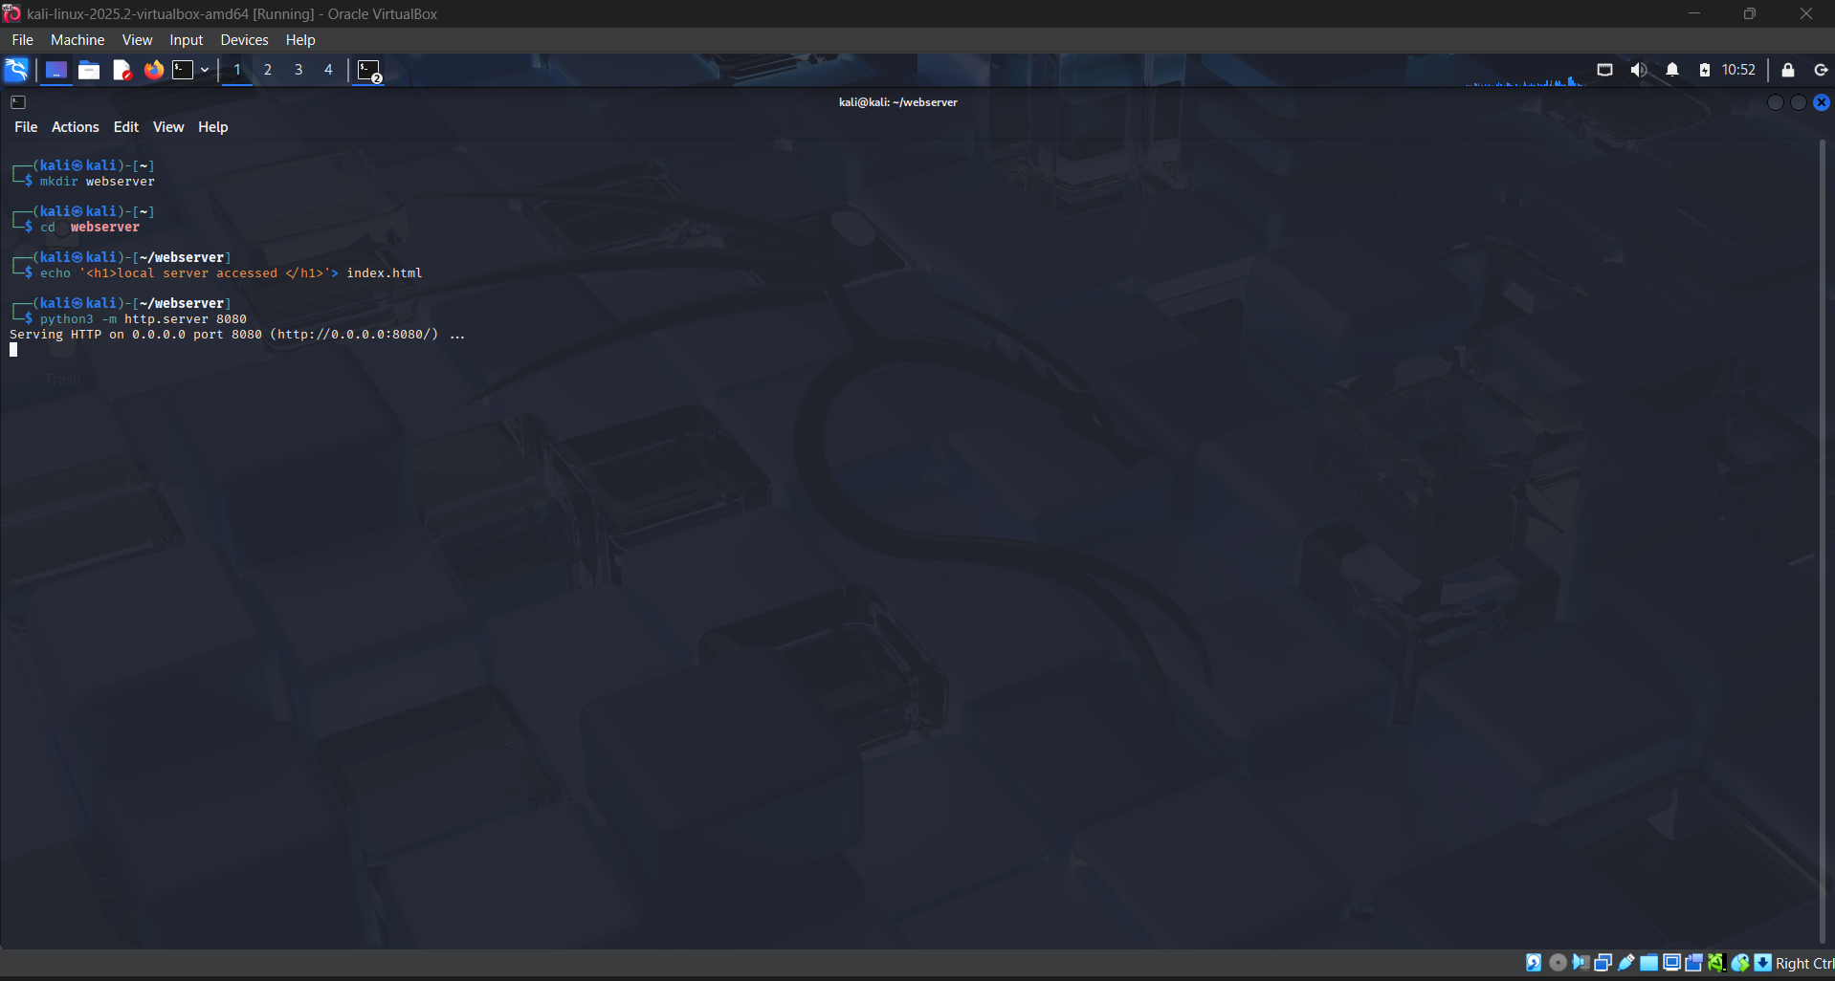

4.Then open the browser and enter http//:localhost:8080 then the html file would be accessed.

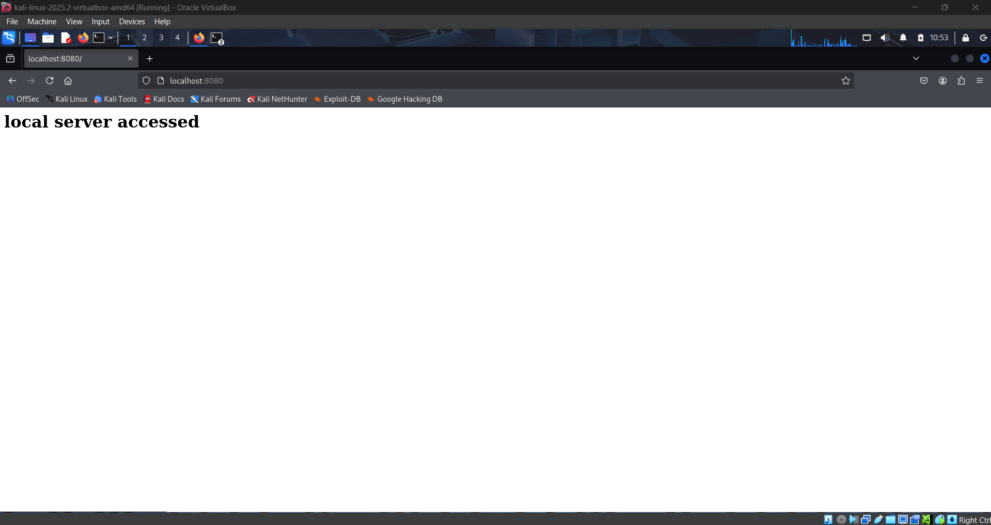

5.Then the terminal would show like a data which is the webserver’s log entry.

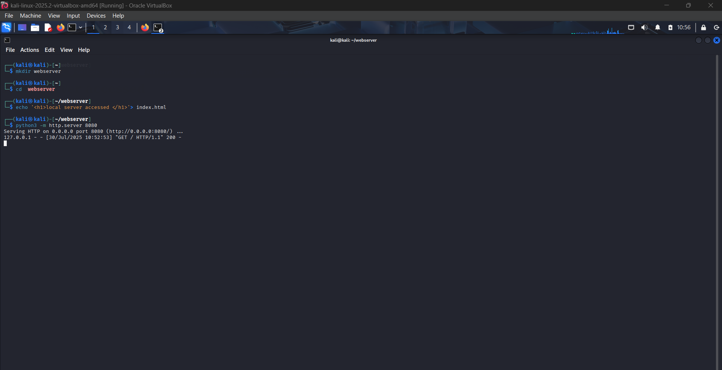

Findings and Conclusions

Python’s built-in HTTP server is useful for quickly testing or sharing files locally.  
The server lacks authentication and encryption, making it unsuitable for public use.

Without an index.html, directory listing is shown, which can leak file names a security risk.

Learned how web servers expose files, how clients make HTTP GET requests, and how logs record those interactions.